TASK 5 – Static Members and Garbage Collection
Aim
To understand static variables, static methods, static blocks, and garbage collection in Java using the Campus Smart-Parking System.

1. Java Program
class ParkingFacility {
static int totalVehicles = 0;
int vehicleCount;
// Static block
static {
System.out.println("Parking System Initialized");
}
ParkingFacility() {
vehicleCount++;
totalVehicles++;
}
// Static method
static void displayTotal() {
System.out.println("Total Vehicles: " + totalVehicles);
}
void displayVehicleCount() {
System.out.println("Vehicle Count: " + vehicleCount);
}
public static void main(String[] args) {
ParkingFacility p1 = new ParkingFacility();
ParkingFacility p2 = new ParkingFacility();
p1.displayVehicleCount();
p2.displayVehicleCount();
ParkingFacility.displayTotal();
}
}
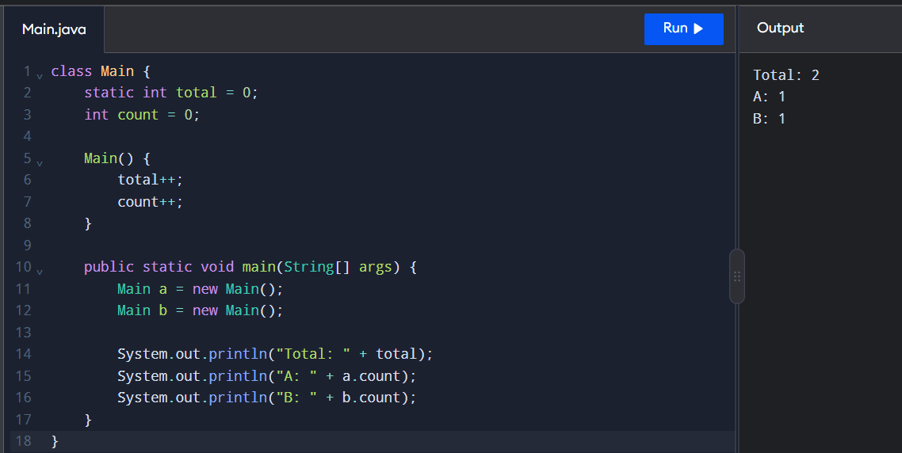

2. Expected Output
Parking System Initialized
Vehicle Count: 1
Vehicle Count: 1
Total Vehicles: 2

3. Explanation
- Static variable: totalVehicles is shared by all objects of the class.
- Instance variable: vehicleCount belongs to each individual object.
- Static method: displayTotal() displays the total number of vehicles.
- Static block: Executes once when the class is initialized.
- Garbage collection: Java automatically reclaims memory occupied by objects that are no longer reachable.

4. Static Counter vs Instance Counter
Static Counter | Instance Counter
Shared by all objects | Separate for each object
Declared using static | Declared without static
Tracks the overall count | Tracks an individual object's count
Accessed using the class name | Accessed using an object reference

5. Alternative Approach
An instance counter can track vehicles separately for each parking floor. A static counter can track the total number of vehicles across the entire parking facility.
Note: In a real parking application, the total occupied-slot count should also be updated when a vehicle exits. The example above demonstrates object creation only.

Result
Static variables, static methods, and static blocks were implemented successfully. The program demonstrates the difference between static and instance variables and explains the role of garbage collection in Java.

